AP Physics Feud User Manual
By Seth Baum
This version: November 23, 2007

Introduction

AP Physics Feud is based on the popular television game show Family Feud. It is designed as a group study/review activity for AP Physics students. It consists of a series of HTML and javascript files that should run on most internet web browsers. The files can be downloaded to a computer’s hard disk space so that the game can be played where there is no internet access. The game works best when it can be projected on a screen or wall so that a larger group of students can play, but those without access to such equipment may find other means of making the game work.

Authors

The game was designed by Seth Baum while a PhD student in electrical engineering at Northeastern University and a National Science Foundation GK-12 Fellow. The game was made for the AP Physics class at the John D. O'Bryant School of Math & Science in Boston, MA, USA, with the assistance of teacher Steve Fernandez. As of November 23, 2007, the game is available for free download at
http://sethbaum.com/education/games/feud/APphysics/

To Begin Play

Open the file “index.html” in the folder “play”.

Making New Games Or Game Rounds

The current version of the game is customized as a general, end-of-year review for AP Physics students. However, the Feud format can be adapted to many other classes or other scenarios. We encourage creative use of the code we have developed. All we ask in return is that you inform us of what you use it for and provide us with your modified versions, so we can continue to serve as a central resource for the Feud series.

New versions can be made by changing the content of an old version. This can be done with webpage editors such as Dreamweaver or with a simple text editor such as Notepad. Here are basic instructions for making new versions with Notepad using Microsoft Windows XP.

- To open a file in notepad, right-click on it and select “Open With”. If Notepad appears as an option, click on Notepad. Otherwise, click on “Choose Program…” and select Notepad from the list the appears.

- The file that opens up is the webpage’s html code. By changing the html code, you change the appearance of the webpage. Below are screenshots of portions of the file you are likely to want to change. The specific lines of the file you are likely to want to change are underlined in red.

The webpage title:
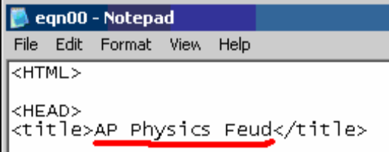

The pop-up answers:
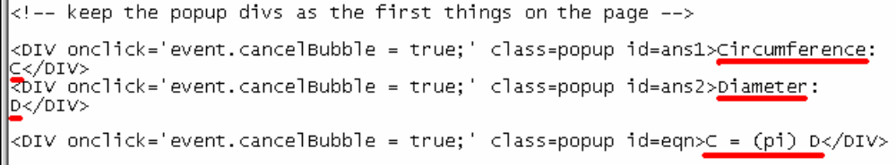
Note: For Games that have more than two answers, simply copy the entire line (from <DIV> to </DIV>) and change the id (from, say, ans2 to ans3). For Games without equations, simply remove the line with the equation.

Page heading and question:
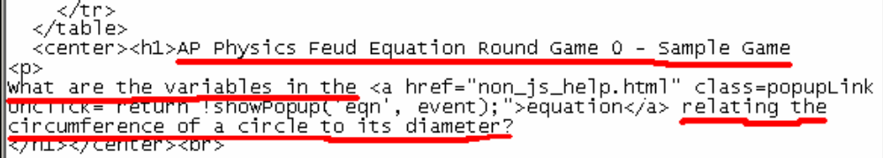

- If your new version has a different number of Games than the old version, you’ll want to change the Game selection page, whose file name is “index.html”. To change this file, simply follow the above instructions and adjust the content of this file to match the new version.

For example:
Here, the text above red line is file name of the Game you need to go to when this link is clicked on; the text above the blue line is the Game’s name, which is the text of the link you’d like to appear.

